**Project Documentation**

**Stock Price Prediction using simple Neural Network**

Name : Kushal Dutia Roll No. : A016

**Machine learning model :**

**Code :**

%pip install yfinance

import yfinance as yf

from datetime import datetime

end = datetime.now()

start = datetime(end.year-20, end.month, end.day)

stock = "GOOG"

google_data = yf.download(stock, start, end)

**Output :**

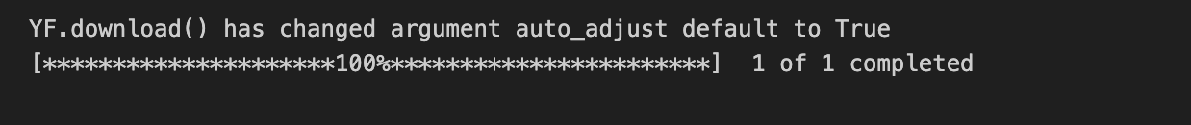

**Code :**

google_data.shape

**Output :**



**Code :**

google_data.info()

**Output :**

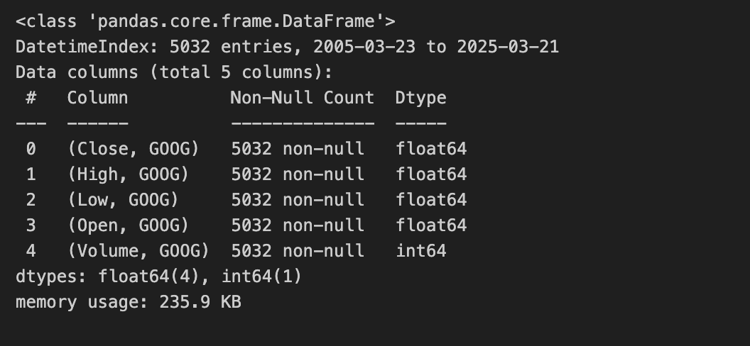

**Code :**

google_data.isna().sum()

**Output :**

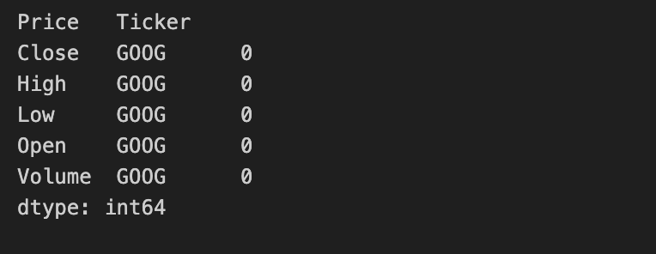

**Code :**

%pip install matplotlib

import matplotlib.pyplot as plt

%matplotlib inline

**Output :**

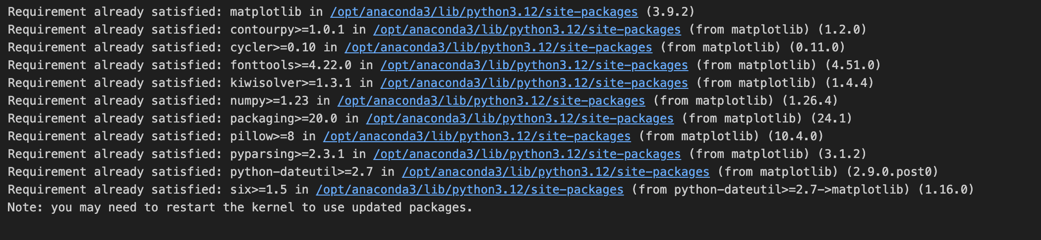

**Code :**

plt.figure(figsize = (15,5))

google_data['Close'].plot()

plt.xlabel("years")

plt.ylabel("Close")

plt.title("Closing price of Google data")

plt.show()

**Output :**

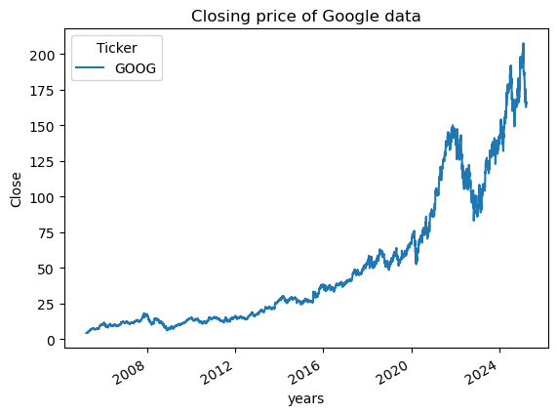

**Code :**

def plot_graph(figsize, values, column_name):

plt.figure()

values.plot(figsize = figsize)

plt.xlabel("years")

plt.ylabel(column_name)

plt.title(f"{column_name} of Google data")

plt.show()

google_data.columns

**Output :**

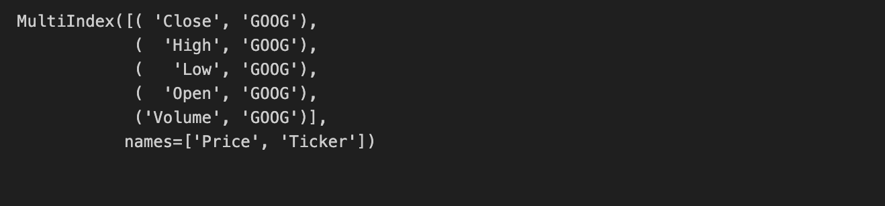

**Code :**

for column in google_data.columns:

plot_graph((15,5),google_data[column], column)

**Output :**

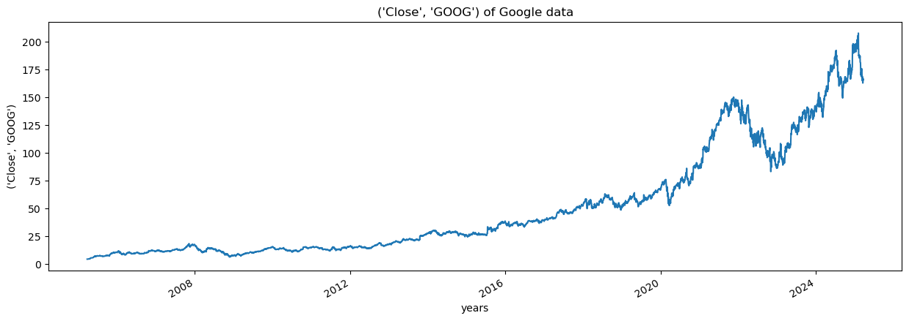

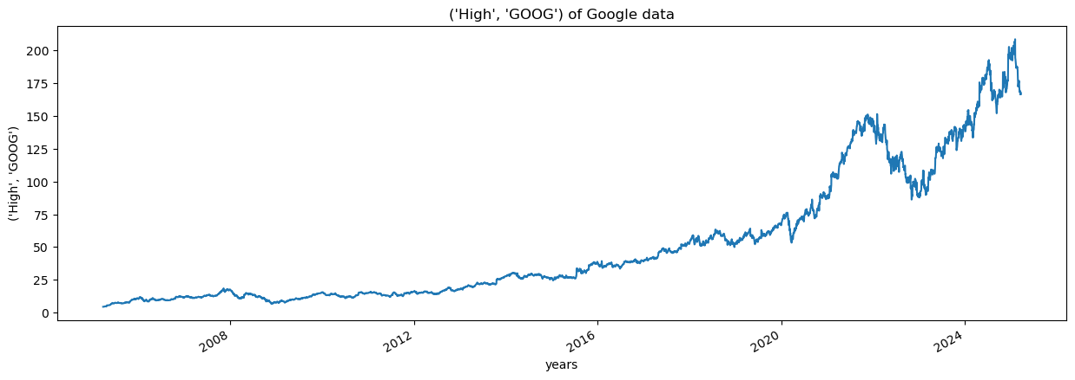

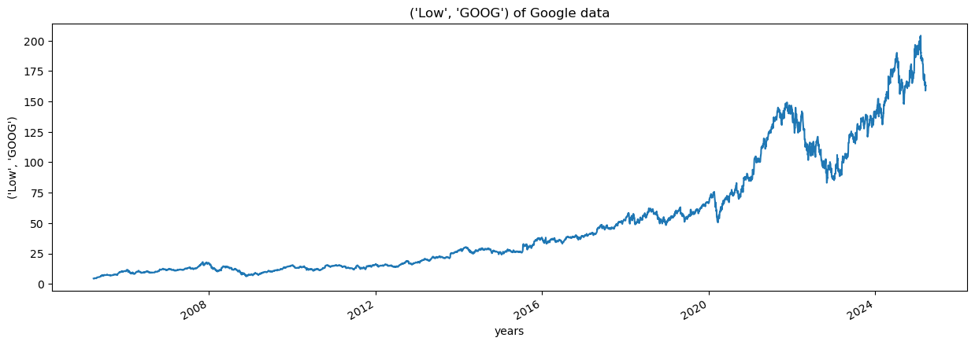

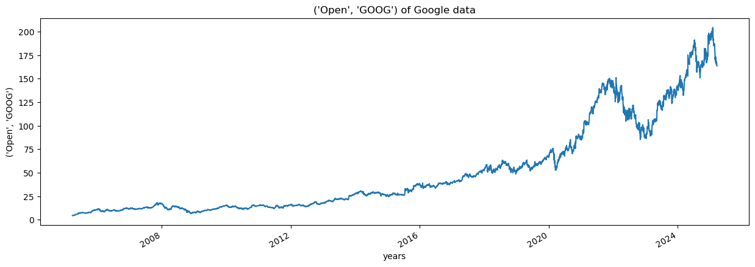

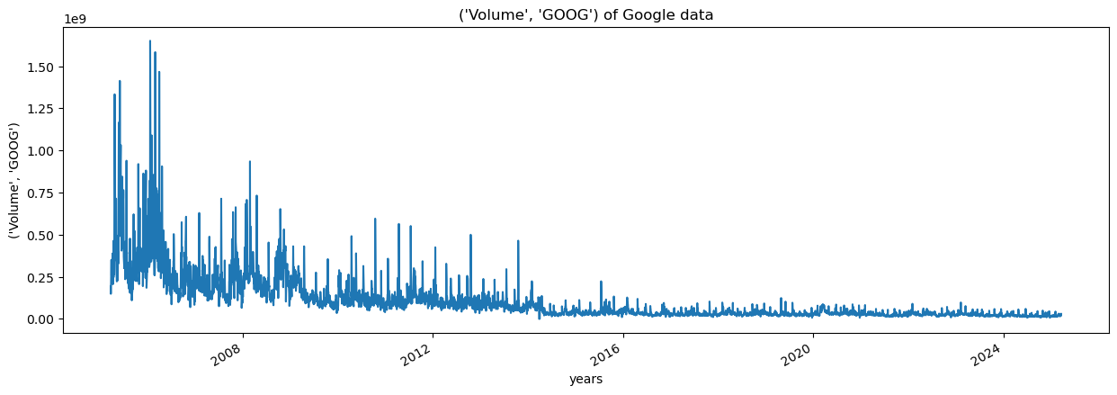

**Code :**

# 10, 20, 30, 40, 50, 60, 70, 80, 90, 100

# MA for 5 days ==> null null null null 30 40 50 60 70 80

temp_data = [10, 20, 30, 40, 50, 60, 70, 80, 90, 100]

print(sum(temp_data[1:6])/5)

**Output :**



**Code :**

import pandas as pd

data = pd.DataFrame([10, 20, 30, 40, 50, 60, 70, 80, 90, 100])

data.head()

**Output :**

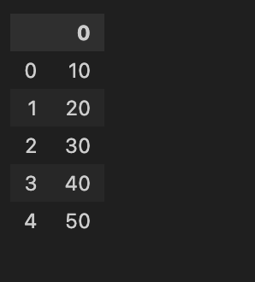

**Code :**

data['MA'] = data.rolling(5).mean()

data

**Output :**

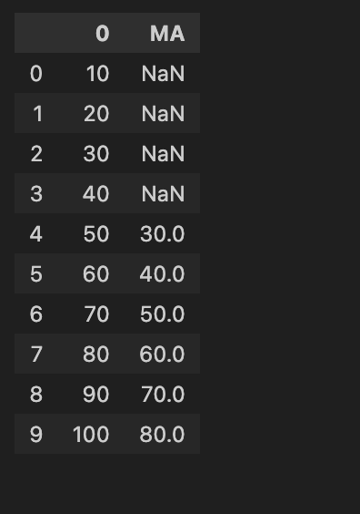

**Code :**

for i in range(2004,2025):

print(i,list(google_data.index.year).count(i))

**Output :**

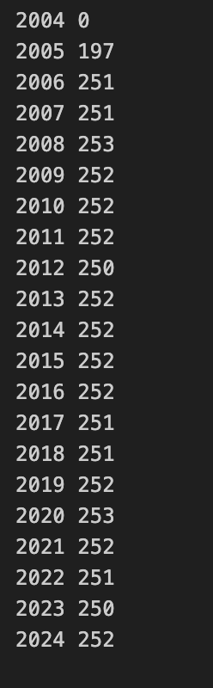

**Code :**

google_data['MA_for_250_days'] = google_data['Close'].rolling(250).mean()

google_data['MA_for_250_days'][0:250].tail()

**Output :**

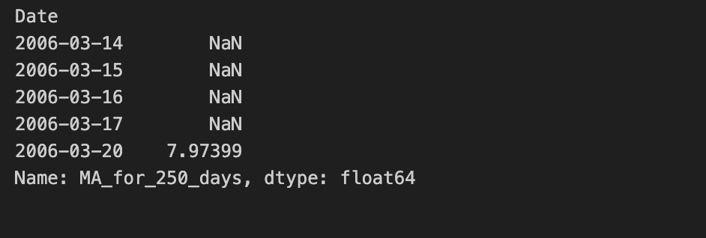

**Code :**

plot_graph((15,5), google_data['MA_for_250_days'], 'MA_for_250_days')

**Output :**

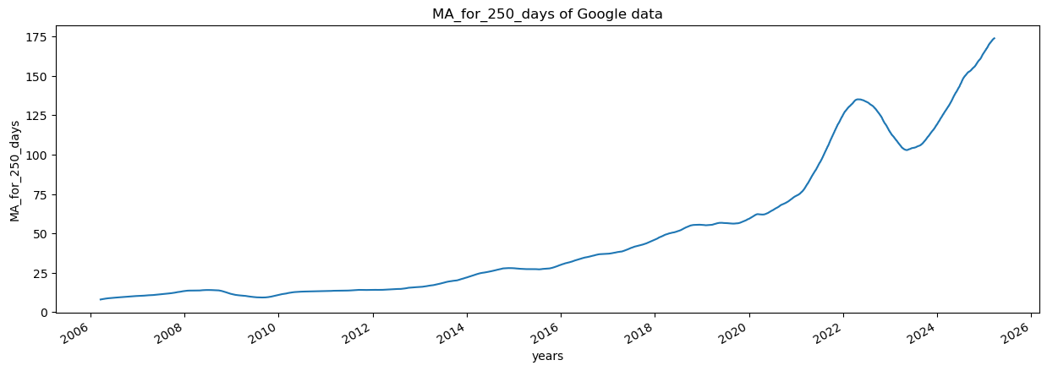

**Code :**

plot_graph((15,5), google_data[['Close','MA_for_250_days']], 'MA_for_250_days')

**Output :**

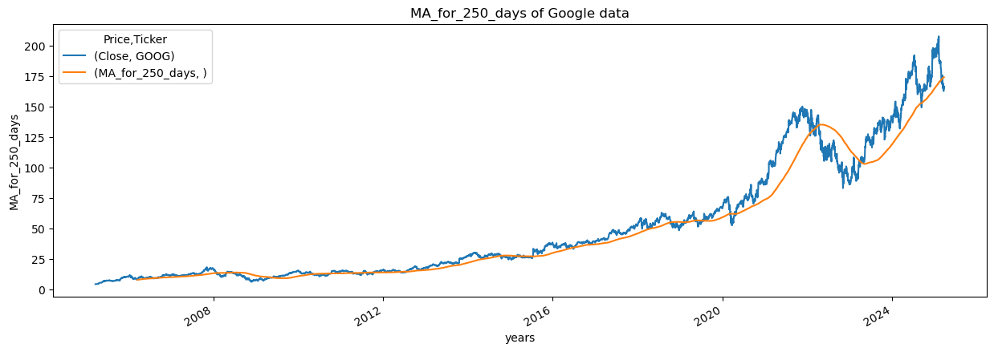

**Code :**

google_data['MA_for_100_days'] = google_data['Close'].rolling(100).mean()

plot_graph((15,5), google_data[['Close','MA_for_100_days']], 'MA_for_100_days')

**Output :** 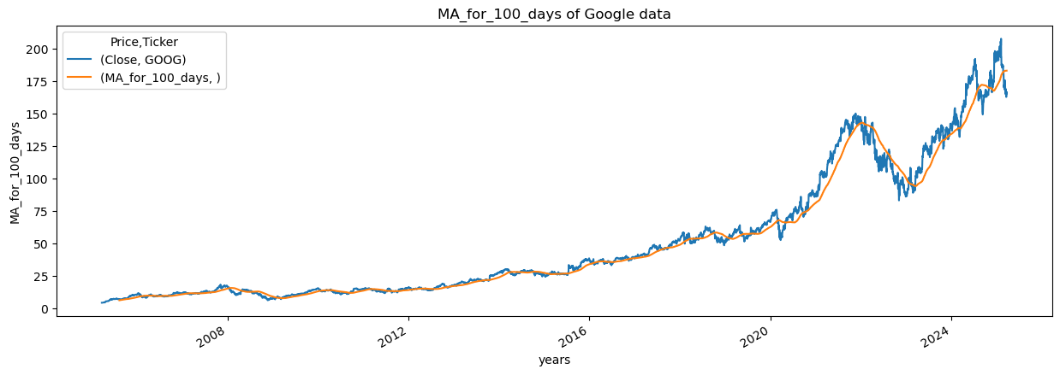

**Code :**

plot_graph((15,5), google_data[['Close','MA_for_100_days', 'MA_for_250_days']], 'MA')

**Output :**

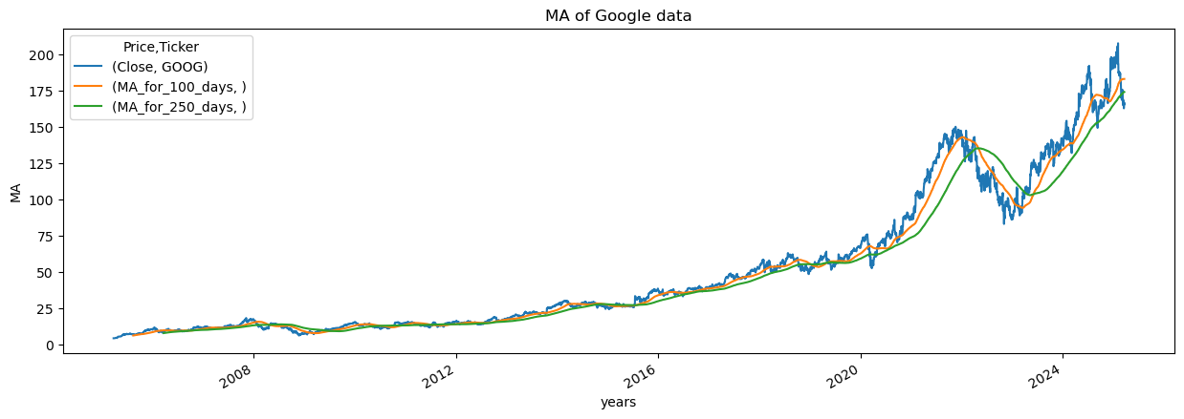

**Code :**

google_data['percentage_change_cp'] = google_data['Close'].pct_change()

google_data[['Close','percentage_change_cp']].head()

**Output :**

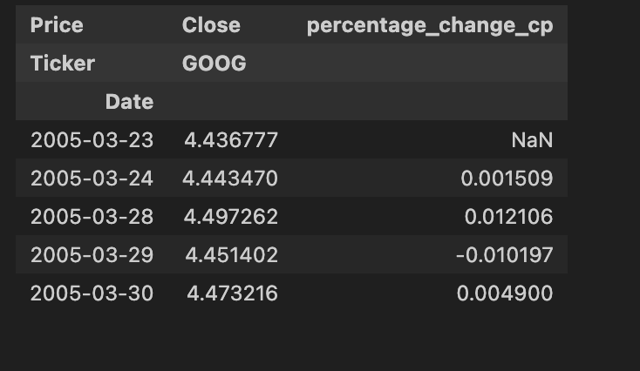

**Code :**

plot_graph((15,5), google_data['percentage_change_cp'], 'percentage_change')

**Output:**

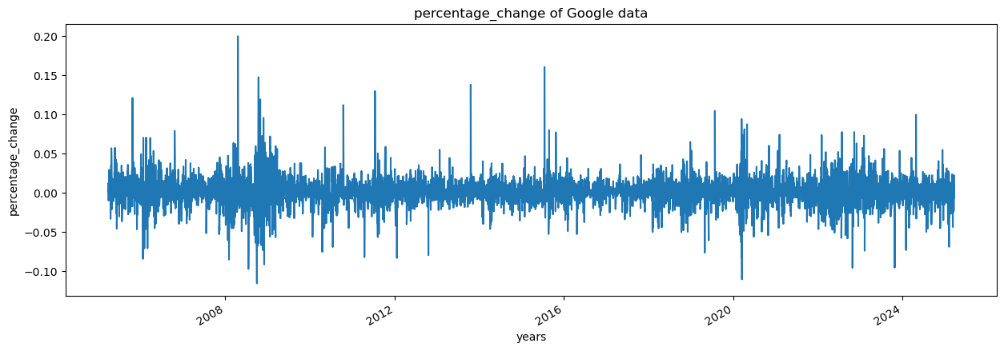

**Code :**

close_price = google_data[['Close']]

max(close_price.values),min(close_price.values)

**Output :**



**Code :**

from sklearn.preprocessing import MinMaxScaler

scaler = MinMaxScaler(feature_range=(0,1))

scaled_data = scaler.fit_transform(close_price)

scaled_data

**Output :**

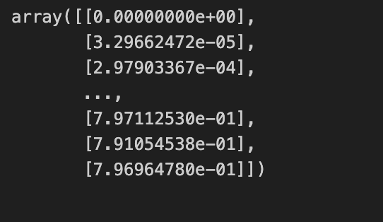

**Code :**

len(scaled_data)

**Output :**

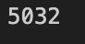

**Code :**

x_data = []

y_data = []

for i in range(100, len(scaled_data)):

x_data.append(scaled_data[i-100:i])

y_data.append(scaled_data[i])

import numpy as np

x_data, y_data = np.array(x_data), np.array(y_data)

x_data[0],y_data[0]

**Output :**

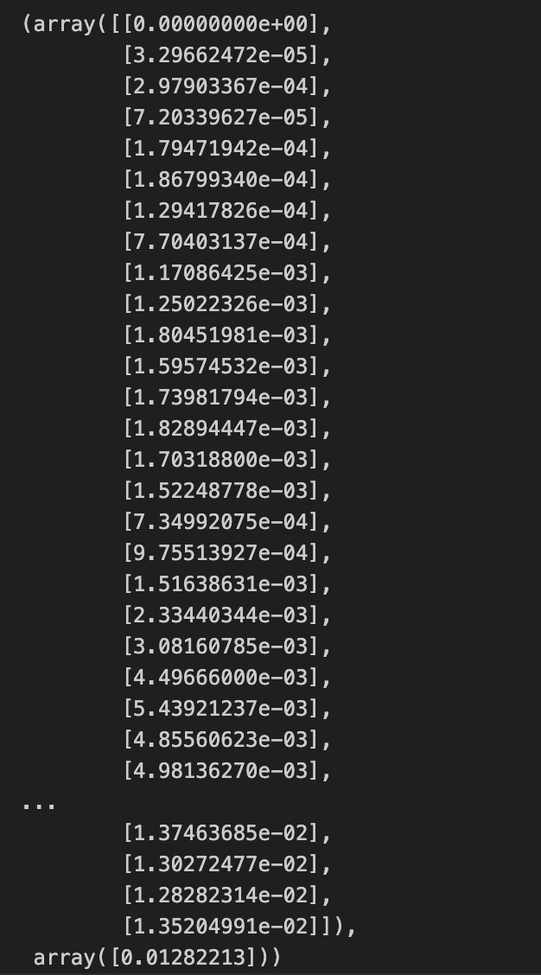

**Code :**

int(len(x_data)*0.7)

**Output :**



**Code :**

4908-100-int(len(x_data)*0.7)

**Output :**

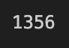

**Code :**

splitting_len = int(len(x_data)*0.7)

x_train = x_data[:splitting_len]

y_train = y_data[:splitting_len]

x_test = x_data[splitting_len:]

y_test = y_data[splitting_len:]

print(x_train.shape)

print(y_train.shape)

print(x_test.shape)

print(y_test.shape)

**Output :**

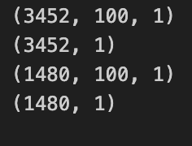

**Code :**

%pip install keras.models

from keras.models import Sequential

from keras.layers import Dense, LSTM

**Output :**

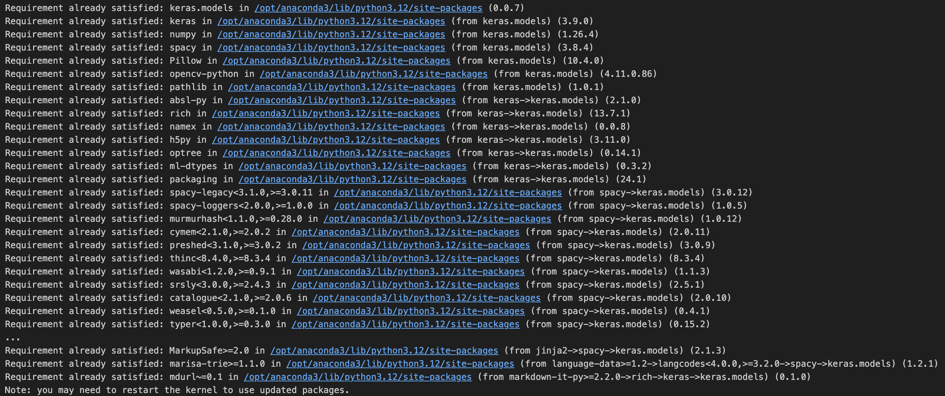

**Code :**

model = Sequential()

model.add(LSTM(128, return_sequences=True, input_shape=(x_train.shape[1],1)))

model.add(LSTM(64,return_sequences=False))

model.add(Dense(25))

model.add(Dense(1))

model.compile(optimizer='adam', loss='mean_squared_error')

model.fit(x_train, y_train, batch_size=1, epochs = 2)

**Output :**

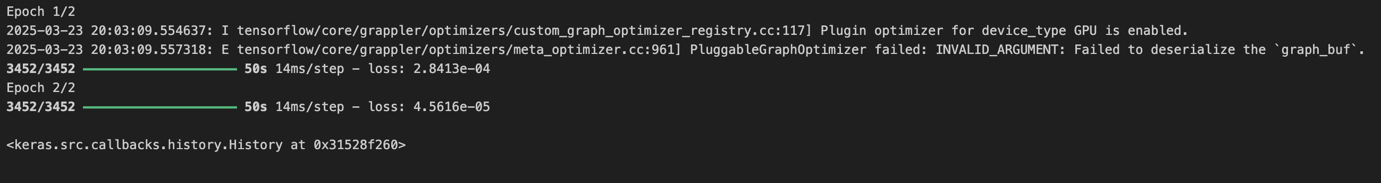

**Code :**

model.summary()

**Output :**

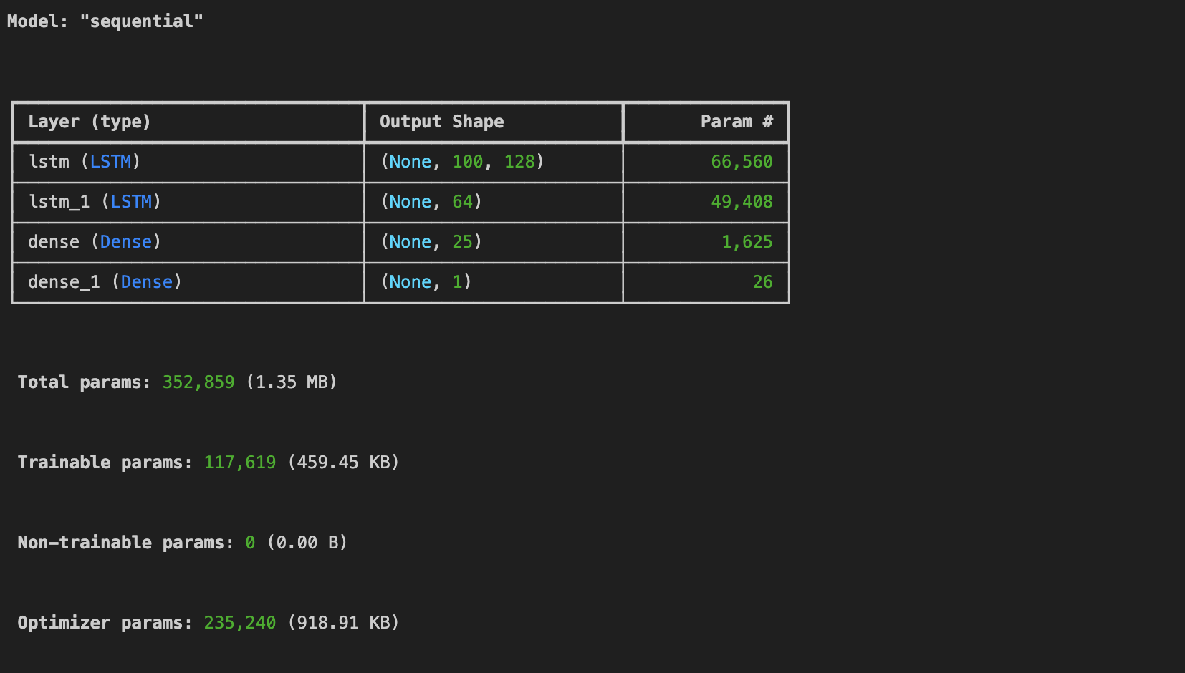

**Code :**

predictions = model.predict(x_test)

**Output :**



**Code :**

predictions

**Output :**

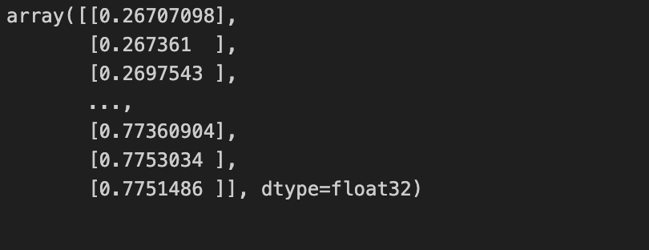

**Code :**

inv_predictions = scaler.inverse_transform(predictions)

inv_predictions

**Output :**

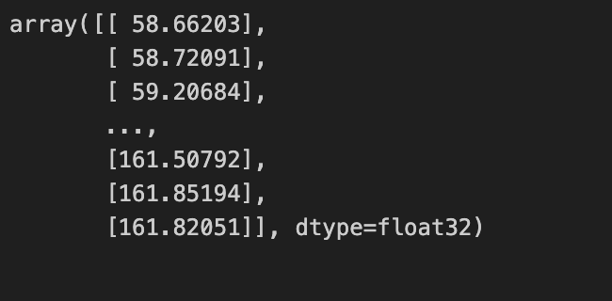

**Code :**

inv_y_test = scaler.inverse_transform(y_test)

inv_y_test

**Output :**

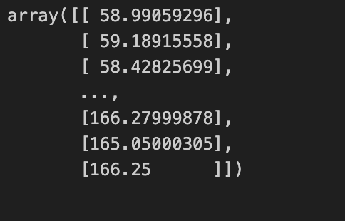

**Code :**

rmse = np.sqrt(np.mean( (inv_predictions - inv_y_test)**2))

rmse

**Output :**

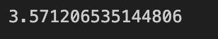

**Code :**

ploting_data = pd.DataFrame(

{

'original_test_data': inv_y_test.reshape(-1),

'predictions': inv_predictions.reshape(-1)

} ,

index = google_data.index[splitting_len+100:]

)

ploting_data.head()

**Output :**

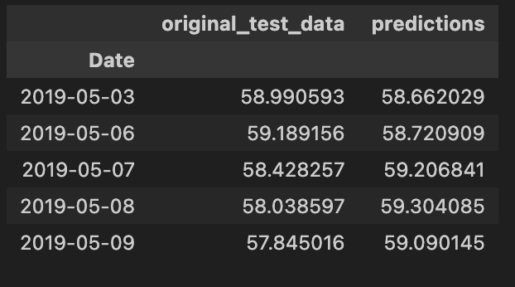

**Code :**

plot_graph((15,6), ploting_data, 'test data')

**Output :**

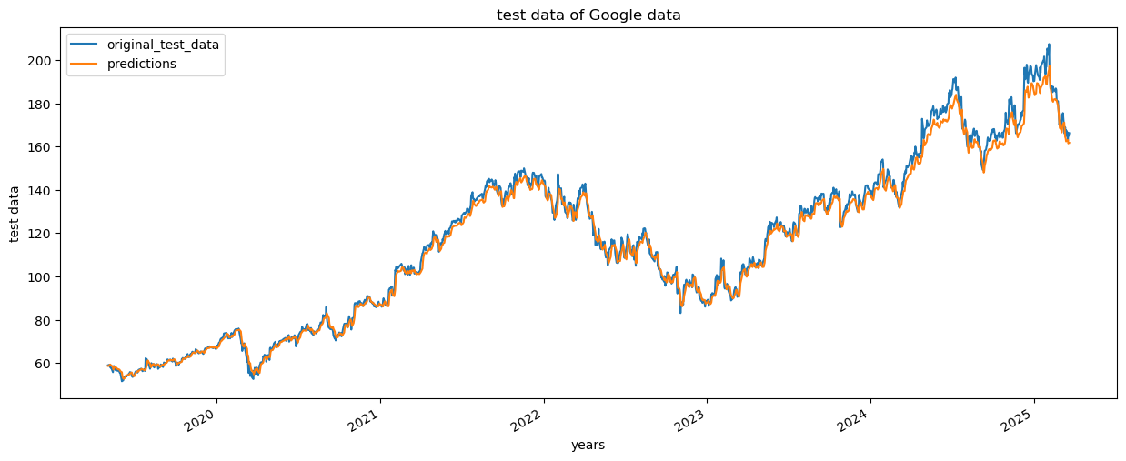

**Code :**

plot_graph((15,6), pd.concat([close_price[:splitting_len+100],ploting_data], axis=0), 'whole data')

**Output :**

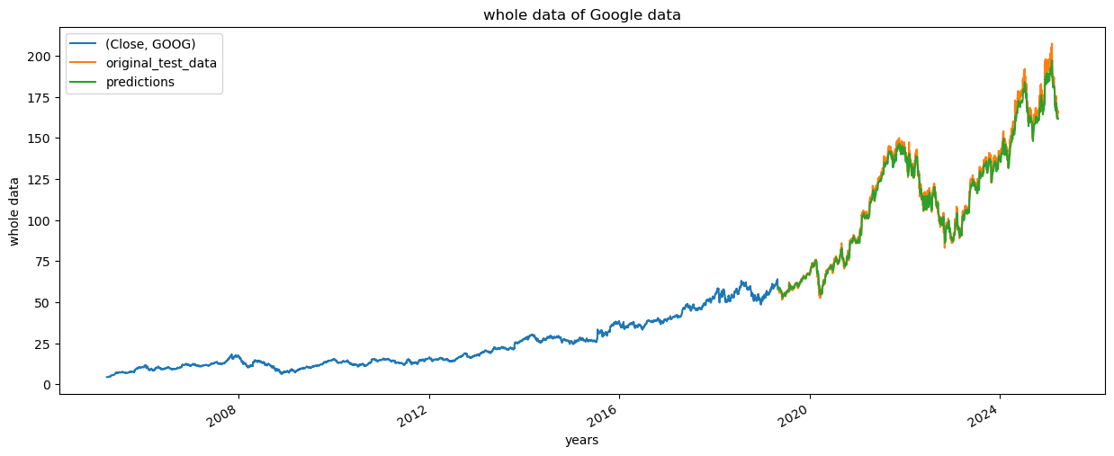

**Code :**

model.save("Latest_stock_price_model.keras")

**Web Development –**

**Code :**

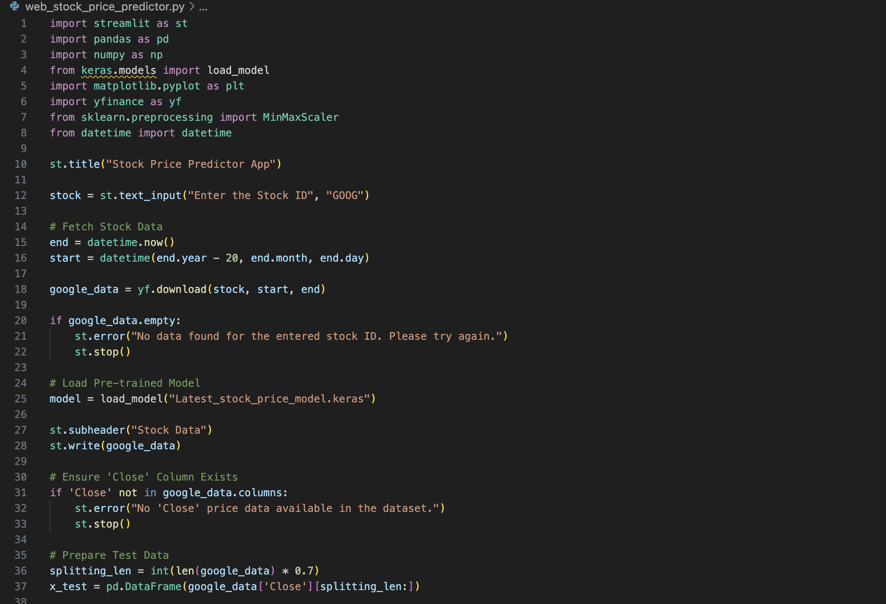

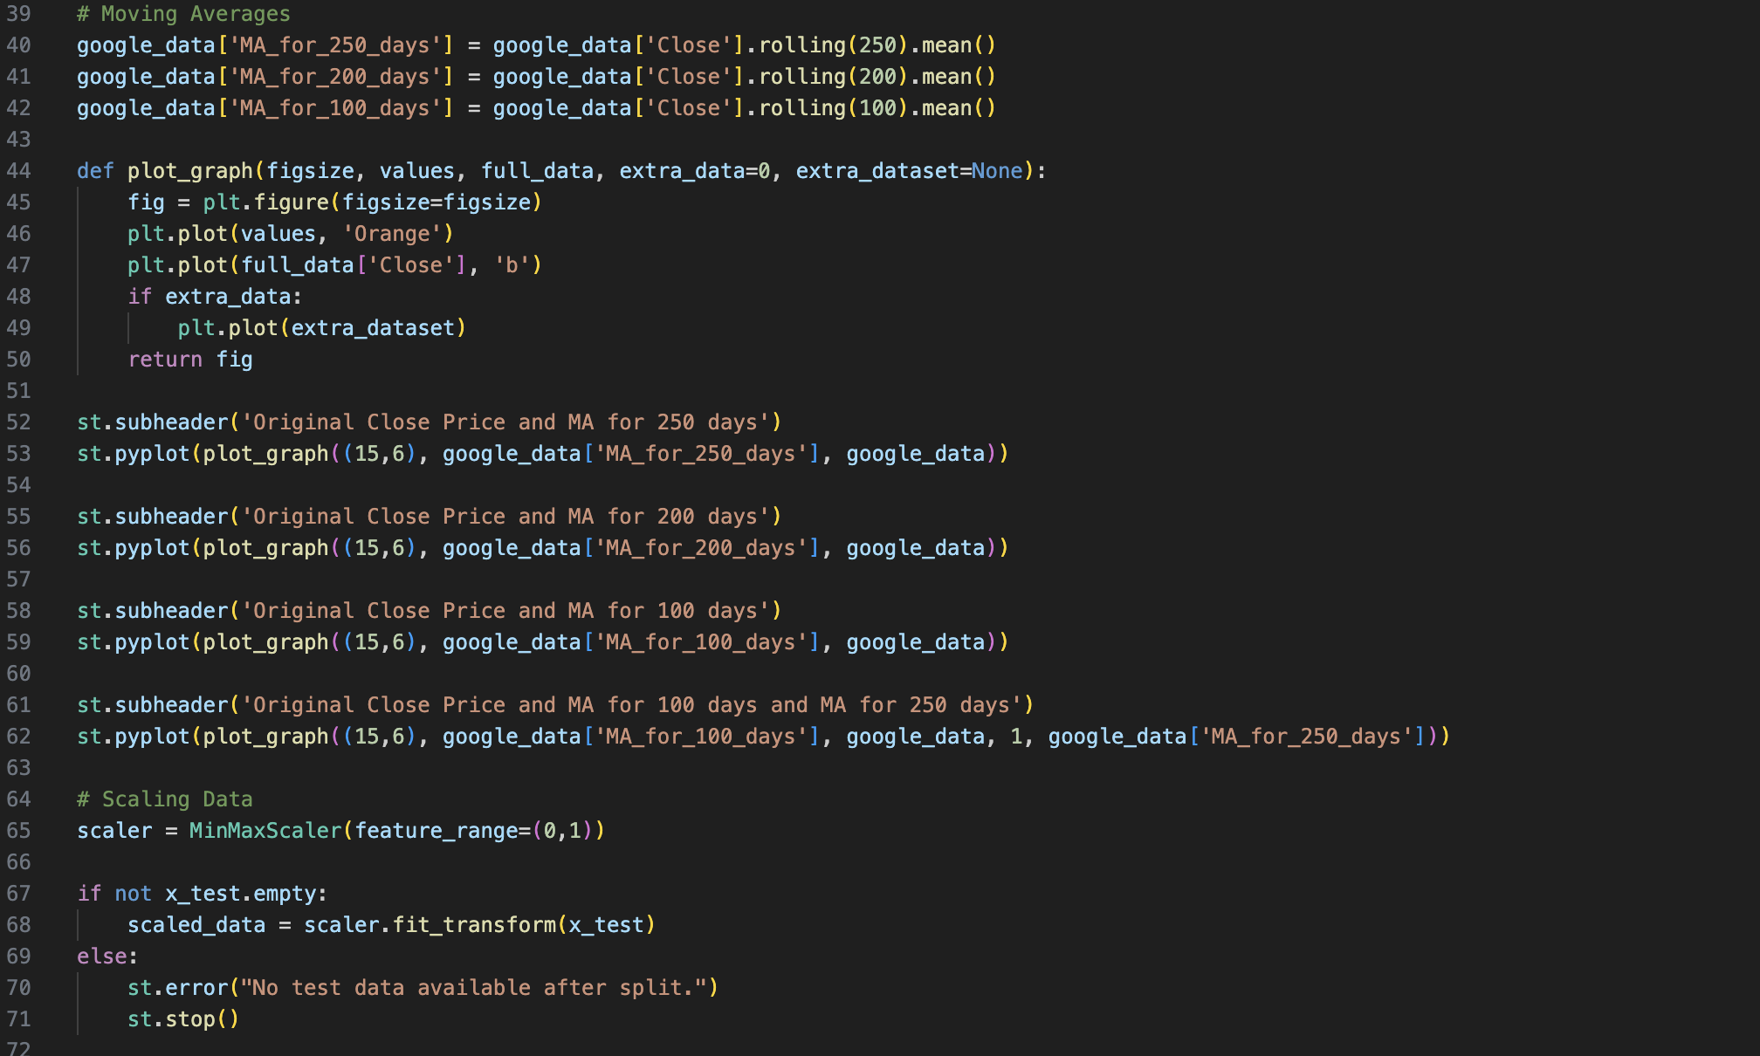

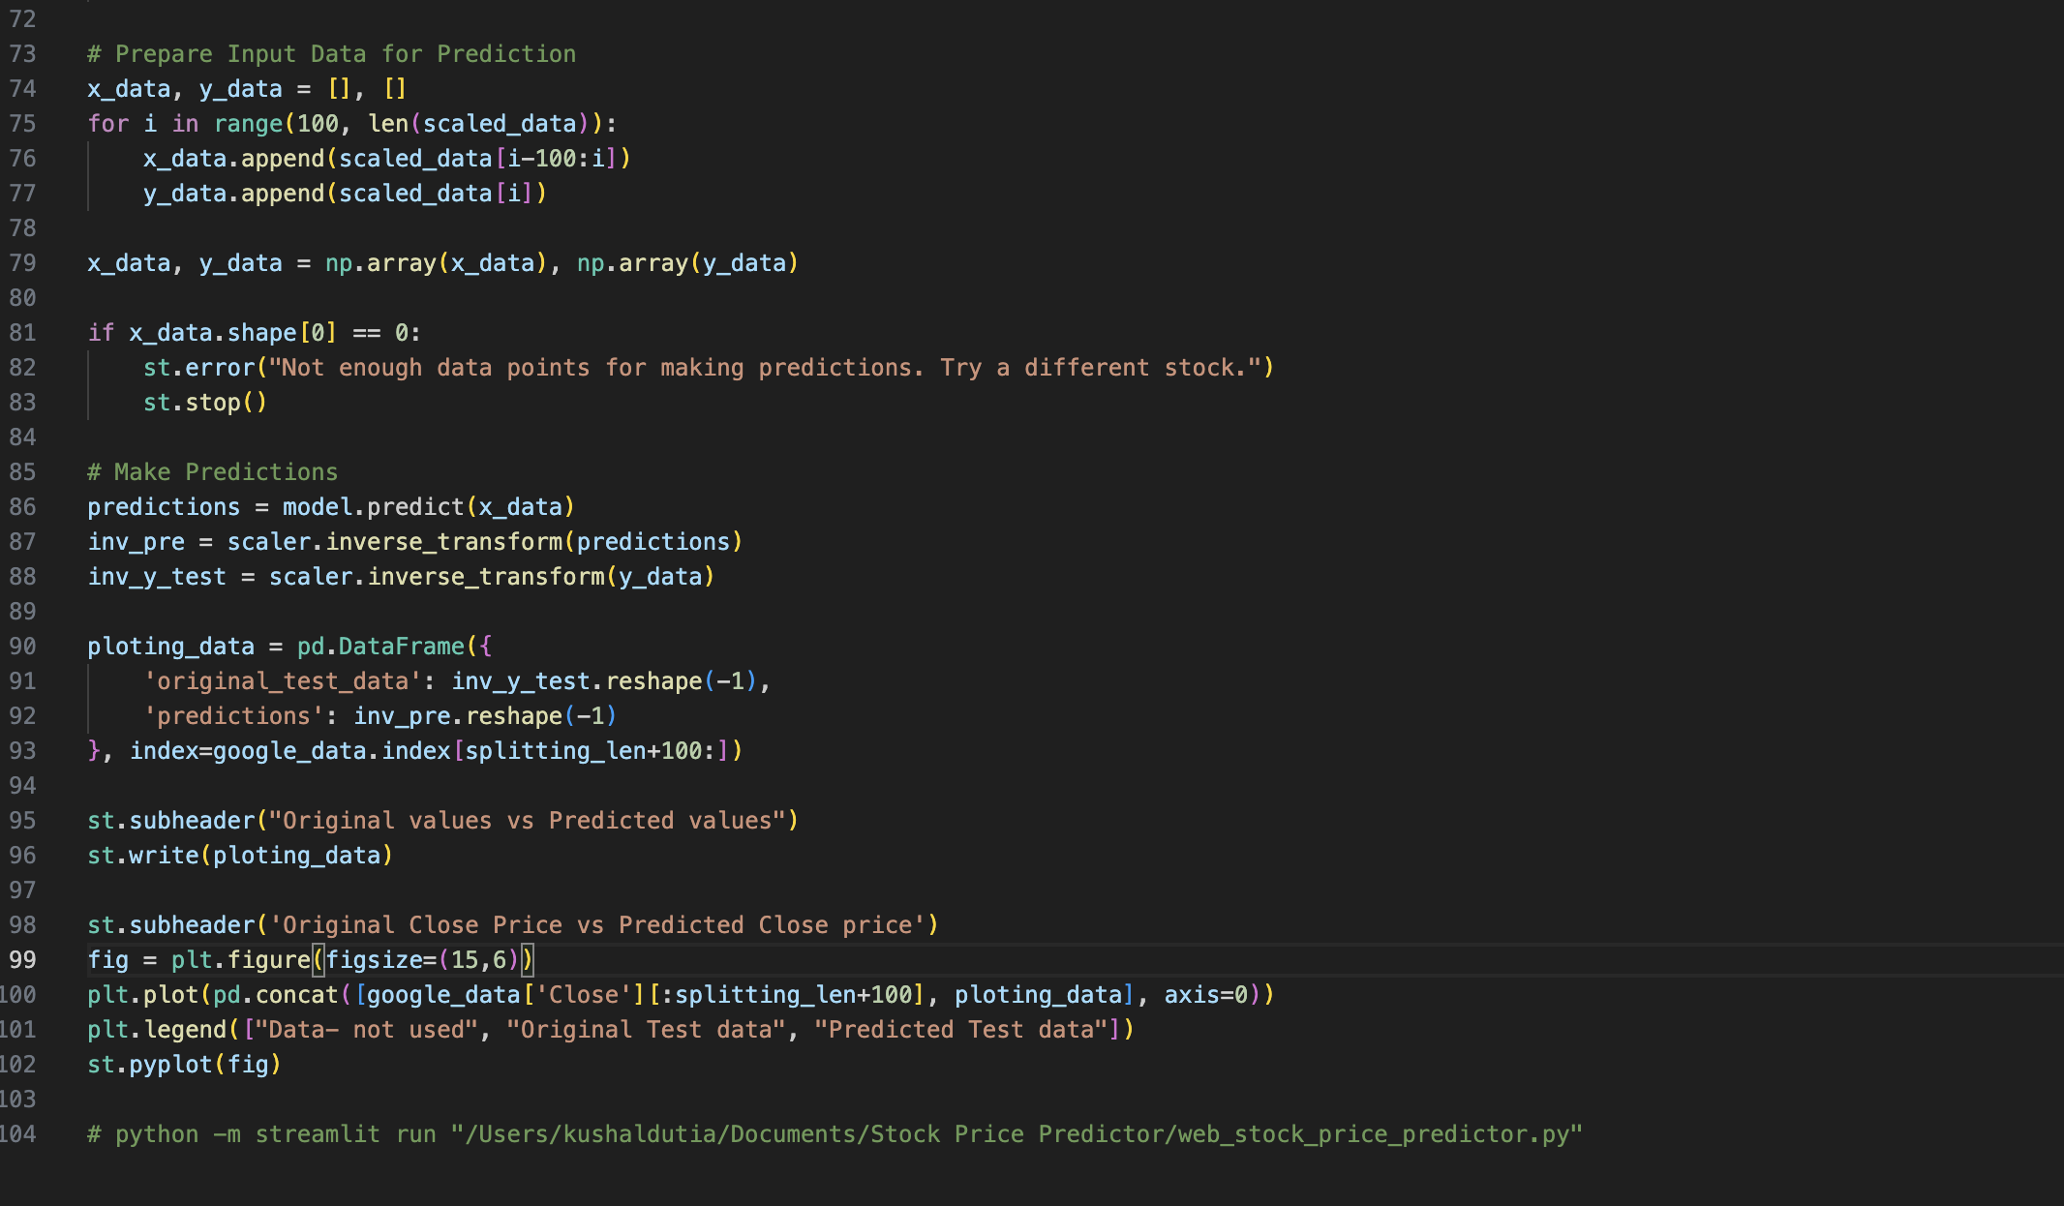

**Website Page –**

